**Assignment - HTML/CSS (Theory Questions)**

**1.How are inline and block elements different from each other?**

Ans:

|  |  |
| --- | --- |
| **Inline Tag** | **Block Tag** |
| They takes up necessary space | They take full width space |
| Eg:- span tag, strong tag | Eg:- div tag, article tag |
| Does not start a newline | Starts a newline |

**2.Explain the difference between visibility:hidden and display:none**

Ans:-

The only difference is “visibility:hidden” elements still take up space on DOM and “display:none” does not.

**4. Explain the difference between absolute, relative,fixed and static.**

**Ans:-**

These are the display properties in a webpage, based on these properties the elements can move on not and if it can then how and with respect to which element it will move

|  |  |
| --- | --- |
| Static | Fixed position of element and does not move. |
| Relative | Can move anywhere w.r.t its own original position. |
| Fixed | Can move anywhere w.r.t viewport’s position. |
| Absolute | Can move anywhere w.r.t its parent’s position |

**5. Write the HTML code to create a table in which there are 4 columns( ID , Employee Name, Designation, Department) and at least 6 rows. Also do some styling to it.**

**Ans:-**

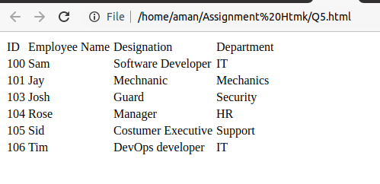

**6. Why do we use meta tags?**

**Ans:-**

These tags are used to specify metadata about the HTML document. They can store description of the page, charset used in the page and also the keywords associated with the page. They don't show up on screen and they are defined in the head tag.

**7. Explain box model.**

**Ans:-**

Content:- this is data we put on the page in tags.

Padding:- Internal Spacing between text and element shell.

Border:- Space between internal space of text and the elements outer line

Margin:- Outer spacing between two elements.

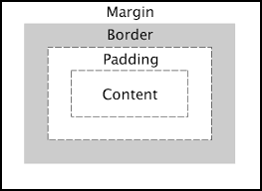

**8. What are the different types of CSS Selectors?**

**Ans:-**

Selector is CSS are:

1. ID :- It uses Id to apply styling on an element and it is denoted by “#”.
2. Class:- It uses class to apply styling on the element and it is denoted by ‘.’ (dot) symbol. We can mention class in almost every element and all the styling we mentioned in class would be applied to that particular element.
3. Element:- It uses element name to apply style. We use element name and put style into it and all the elements that are of mentioned type will be styled that particular way. Eg:- img { }
4. Universal Selector:- This selects all the elements in the webpage it is denoted by (*) asterisk.

**9. Define Doctype.**

**Ans:-**

This is used to specify which type of document it is. This is a declaration tag which lets browser know which type of document this is. For example in HTML 5 we write <!DOCTYPE HTML> to let the browser know that it is a HTML document.

**10. Explain 5 HTML5 semantic tags.**

|  |  |
| --- | --- |
| **Tag** | **Description** |
| **<article>** | **Used to write full-fledged articles** |
| **<nav>** | **Used to put links at one place** |
| **<footer>** | **Used to add content at the bottom area of webpage** |
| **<header>** | **Used to add content at the top area of webpage** |
| **<aside>** | **Used to add content at the left area of webpage** |

____________________________________________________________________________________________________________________________________________________________________________________________________________________________________

**Undone:-**

**3. Explain the clear and float properties.**

**Ans:-**

**Float:- This is used to to position an element on the left or right side of another element or container.**

**Variations:-**

1. **left - The element floats to the left of its container**
2. **right - The element floats to the right of its container**
3. **none - The element does not float (will be displayed just where it occurs in the text). This is default**
4. **inherit - The element inherits the float value of its parent**

**Clear:- This is used by an element so that other elements cannot float over this element.**

**Variations:-**

1. **none - Allows floating elements on both sides. This is default**
2. **left - No floating elements allowed on the left side**
3. **right- No floating elements allowed on the right side**
4. **both - No floating elements allowed on either the left or the right side**
5. **inherit - The element inherits the clear value of its parent**